Why do we use it? IU Health is committed to having a secure environment to protect our patient data from cyber attacks. Therefore, there are different ways to access the internet at IU Health based on what information will be accessed and by whom.

If I have… | I will use…
…a personal iOS or Android mobile device enrolled in Workspace One, | …iuhmobile.
…a personal device (iOS (iPhone or iPad), Android, Windows, or Macbook) not enrolled in Workspace One but used for patient care, | …eduroam.
…a personal device not used for patient care, | …IUH Public.

Accessing iuhmobile
Your mobile device must be enrolled in Workspace One (see links to the instructions below) to access the iuhmobile network. Once you complete setup of Workspace One, your device will automatically connect to this network until you change your IU Health password or have not been on the IU Health network for at least 180 days.
- Enrolling User-Owned Android Devices in Workspace One
- Enrolling User Owned iOS Devices in Workspace One

Accessing eduroam (ed-u-roam)
IU Health is part of the eduroam (ed-u-roam) wireless network program, which provides safe and secure internet access to educational institutions such as Indiana University (IU); Indiana University – Purdue University Indianapolis (IUPUI); and their partners. This network program is accessible to personal devices using IU Health, IU, IUPUI, or other participating educational institution credentials. Devices that connect to eduroam at any IU Health facility will automatically connect to eduroam when it is available at a participating institution, which means that you will continue to have Internet access at participating sites without logging-in multiple times.
Jump to the device specific instructions for logging into the eduroam network:

- Personal iOS device
- Personal Macbook
- Personal Android Device
- Personal Windows Device

Connecting on a personal iOS Device (iPhone or iPad)

The purpose of this document is to provide step-by-step instructions for joining the wireless network known as eduroam on personal iOS devices (iPhone or iPad).

Steps with pictures

- On your iOS device, navigate to Settings > > Wi-Fi and press “eduroam” under “Other Networks”

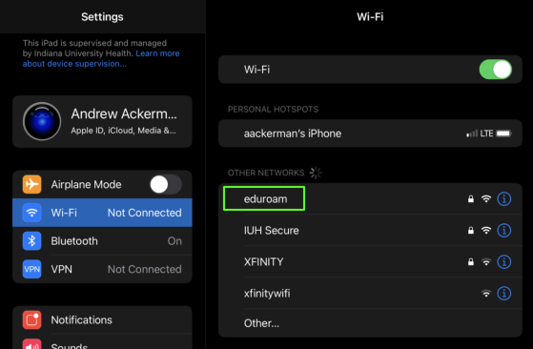

- Enter your log-on credentials in the appropriate boxes:
  - If you have an IU Health username and password enter them in the boxes then click “Ok.” Be sure to include the @iuhealth.org domain to your username.
  - If you have an Indiana University username and password, enter them in the boxes including the correct domain (@iu.edu, @iupui.edu, etc.).

- You will be prompted to trust a certificate named radius.iuhealth.org. Press “Trust” in the far right hand corner.

- You should now be connected to the eduroam wireless network

- Troubleshooting: If you are having difficulties connecting, disable the “Private Address Feature” using the following steps:

Go to Settings > Wi-Fi and press the ⓘ icon to the right of the eduroam network.
  - Press the “Private Address” button/toggle to turn it to the “OFF” position.
  - Press the “Join this Network” text to connect

Please contact the Service Desk at 317.962.2828 if you have any questions.

Connecting on a personal Android Device

The purpose of this document is to provide step-by-step instructions for joining the wireless network known as eduroam on personal Android devices.

Steps with pictures

- On your Android device, navigate to Settings > Connections > Wi-Fi. Press “eduroam” under “Available Networks”

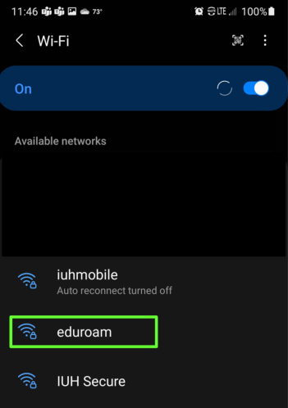

- Enter your log-on credentials in the appropriate boxes:
  - If you have an IU Health username and password, enter them in the Identity and Password fields. Be sure to include the @iuhealth.org domain to your username.
  - If you have an Indiana University username and password, enter them in the boxes including the correct domain (@iu.edu, @iupui.edu, etc).

- Press “CA Certificate” and press the “Don’t validate” option.

- Press “Advanced.” Scroll down until you see the “MAC address type” or a similar setting for MAC address. Press “MAC address type” and select “Phone MAC.”
(If Randomized MAC is selected, your device will not connect.)

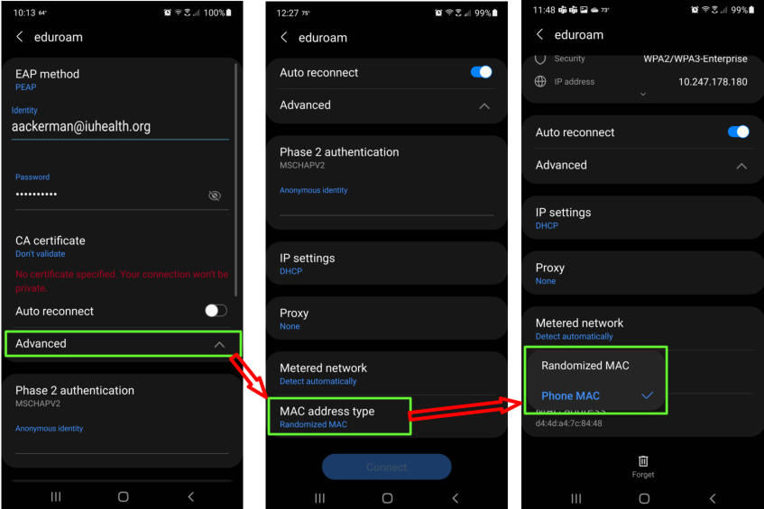

- Press the large “Connect” button at the bottom of the screen

- You should now be connected to the eduroam wireless network.

Please contact the Service Desk at 317.962.2828 if you have any questions.

Connecting on a personal Windows Device

The purpose of this document is to provide step-by-step instructions for joining the wireless network known as eduroam on personal Windows Devices.

Steps with pictures

- Locate and Left Click the Wireless Network Icon on your Task Bar

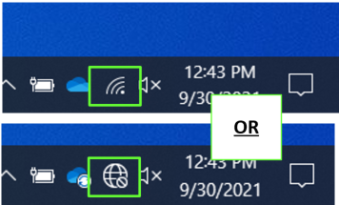

- Select the eduroam icon in the list of available networks.

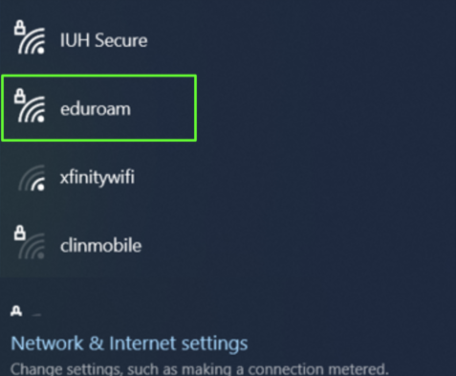

- Enter your log-on credentials in the box.
  - If you have an IU Health username and password, enter them in the boxes then click “Ok.” Be sure to include the @iuhealth.org domain to your username.
  - If you have an Indiana University username and password, enter them in the boxes including the correct domain (@iu.edu, @iupui.edu, etc).

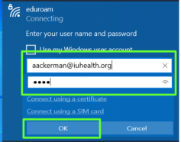

- Select “Connect” at the next prompt

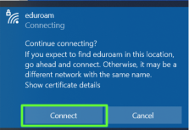

- You should now be connected to the eduroam wireless network.

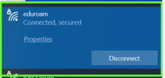

Please contact the Service Desk 317.962.2828 if you have any questions.

Connecting on a personal Macbook

The purpose of this document is to provide step-by-step instructions for joining the wireless network known as eduroam on personal Macbook devices.

Steps with pictures

- Locate and Left Click the Wireless Network Icon on your Task Bar.

- Select the eduroam icon in the list of available networks.

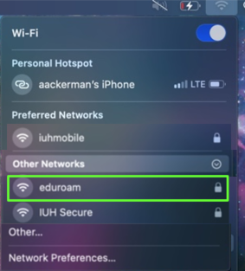

- Enter your log-on credentials in the box.
  - If you have an IU Health username and password, enter them in the boxes then click “Join.” Be sure to include the @iuhealth.org domain to your username.
  - If you have an Indiana University username and password, enter them in the boxes including the correct domain (@iu.edu, @iupui.edu, etc).

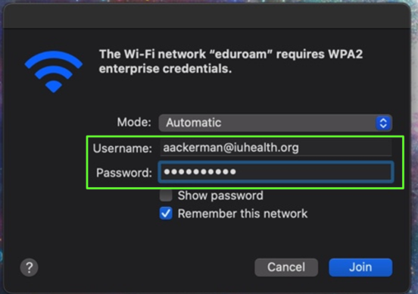

- Select “Continue” at the Verify Certificate prompt.

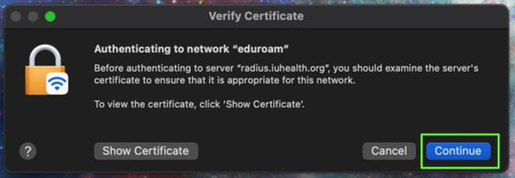

- You should now be connected to the eduroam wireless network.

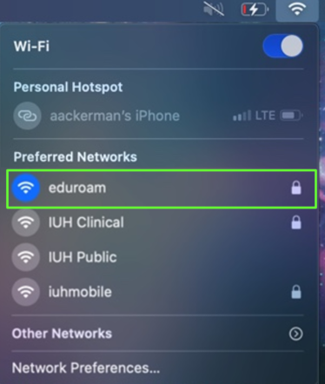

Please contact the Service Desk at 317.962.2828 if you have any questions.

Accessing IU Health Public
This network is for patients or guests at IU Health facilities.

- Connect to IU Health Public by selecting “IU Health Public” on your Wi-Fi screen

- You will see the following screen.

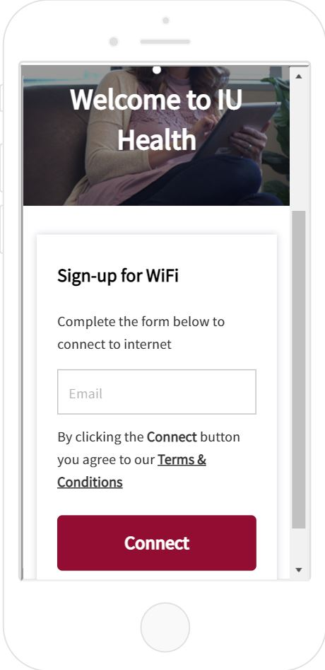

- Enter your email to accept the “Terms and Conditions” for guest wireless connections and press “Connect”

- You are connected!

