Parking Update: Riley Maternity Tower
The following are anticipated questions regarding the second phase of a strategic approach to deliver parking solutions for patients, visitors and team members at Riley Hospital for Children. This phase delivers safe, reliable parking options for team members coming from Methodist as part of the Maternity Tower project which will open in Fall 2021 to provide safe care for moms and babies in a range of OB scenarios. The first phase of parking launched in early 2021 and prioritized patients who needed to receive Riley outpatient care and have easier access to those services by parking in the Riley Outpatient Center (ROC) garage. That phase involved moving some Riley team members from the ROC garage to other garages or surface parking.
These parking solutions have been developed by The Riley Parking Task Force which has been working collaboratively with (IU Health, IUPUI) to improve the parking experience for all parkers. The Task Force has been focused on solutions to best meet parking needs related to reliability, cost, convenience, proximity to buildings, accessibility, safety and future needs for expansion/growth are all considerations reviewed.

Have a question not addressed below? Please submit your question directly to the Parking Task Force HERE

Newly added (8/30/21):
What is the process for obtaining permits for new team members?
Here is the process for obtaining those permits:

For current employees who did not complete the parking permit form at Orientation, missed the deadline or have been hired since 8/1/2021:
- Send team member name and 9-digit employee number to Kimberly Brown or Michele Holden in the Safety and Security Office. They will email IUPUI Parking regarding the permit
- Team members will report to the Vermont Street Parking Services office located at 1004 W. Vermont Street to pick up their permits

For new hires starting on or after 9/12/2021:
- Team members will provide parking information during Onboarding visit to the LaunchPad where they will have their photos taken and submit information to be sent to Parking Services. Please note: If team members don’t go to the LaunchPad prior to their start date, they will not receive a badge or parking permit.
- Team members will receive parking permits at Riley New Team Member Orientation
Please note: Safety and Security will copy the team member on the approval email sent to IUPUI Parking. When the email is received, team members can visit IUPUI Parking to obtain their permits.
I understand there are special circumstances when someone may park in the Simon Family Tower. How will those times be handled?
Nursing staff will have access to passes for a patient support person, staff covering a shift for another team member, and or a staff member coming in to cover unscheduled shifts.

Can Evening garage permits be used in garages with “Students Only” signage?
No.

Some team members work a few evenings and some days. Is there a parking solution for this situation?
While there isn’t a pass that specifically meets that criteria, the Parking Task Force is working on a solution to meet the needs of these team members.

How will the Stork Team get to Methodist in the event we need to mobilize for an emergent delivery at Methodist?
When the Stork Team is activated, there is a number to call and a reserved police car that will take the team to Methodist. The Denison supervisor will drive the Stork Team with Security as the backup driver.

On weekends, can day shift staff park in the garage with the EM pass?
No, the EM pass is only for the surface lot. Typically, on the weekends the surface lots are very open, and team members can usually park in a spot in the front dental lot.

Previously answered questions and answers begin here:
If someone completed the form but since changed their mind on their selected option, how should they make the Parking Task Force aware? Will the person need to resubmit the form and how will the person make their new selection known to reverse their decision?
If someone has completed the form and changed their mind about their election, that person should send an email to Riley Parking, rileyparking@iuhealth.org. The team member will need to complete and submit the form again HERE to indicate which selection should be deleted and indicating their final election.
How will parking work for patients/families and other visitors at the Maternity Tower?
Reliable parking is an important way for us to show our patients and visitors that we care. For patients and visitors:
- After the Maternity Tower opens in Fall 2021, Riley will have valet parking 24/7 with no cost to patients.
- Inpatients will receive a flex pass for the Simon Family Tower (SFT) that is valid for free in and out parking during the duration of their stay.
- Outpatients will receive $2 parking validations, which are valid in both the ROC and SFT garages.
- Visitor Parking is an hourly rate (ROC and SFT are the same rate).

If I work during the day shift at the Maternity Tower, where will I park? What will it cost?
Reliable parking is an important priority for Riley Team Members. For team members working at the Maternity Tower during the Day Shift, there are options.
EM Permit:
- Team members who select the EM Permit option have access to the following spaces (EM, ST and NC surface spaces).
- Free to team members.
- The annual cost is covered by IUH/IUHP.
Garage Permit:
- Cost covered by team member ($910.44 annually)
- Limited number of spaces available for Maternity Tower move.
- Waitlisted approach will be used if there is interest above limited spaces.

For team members working at the Maternity Tower on the Evening/Night/Weekend shifts, there are options.
Evening/Night/Weekend Parking Permit:
- Evening parking permit is free to team members. The cost is covered by IUH/IUHP.
- It is valid only between 2 pm – 9 am Monday through Friday in EM, ST and NC surface spaces and permit garages (excludes student garages).
- This permit is valid all day on weekends (Saturday/Sunday) and University Holidays in EM, ST, & NC surface spaces and permit garages (excludes student garages).

Reliable parking is an important priority for providers working at the Riley Maternity Tower.
With that in mind, For Provider Parking:
- The Riley Parking Task Force is undergoing an effort to capture data to:
  - Understand demand – not total volume
  - Align with current physician parking strategy

Will there be options for me if I have a disability (D)?
Team members who qualify will work with IUPUI to obtain a disability (DI) permit for use when parking for work in the Maternity Tower. This will include providing appropriate documentation from your medical team.

What are the costs for my parking options while working in the Maternity Tower?
For team members working at the Maternity Tower during the Day Shift, there are options.
For Day Shift – EM Permit:
- Team members who select the EM Permit option have access to the following spaces (EM, ST and NC surface spaces).
- Free to team members.
- The annual cost is covered by IUH/IUHP.
Garage Permit:
- Cost covered by team member ($910.44 annually)
- Limited number of spaces available for Maternity Tower move.
- Waitlisted approach will be used if there is interest above limited spaces.

For team members working at the Maternity Tower on the Evening/Night/Weekend shifts, there are options.
Evening/Night/Weekend Parking Permit:
- Evening parking permit is free to team members. The cost is covered by IUH/IUHP.
- It is valid only between 2 pm – 9 am Monday through Friday in EM, ST and NC surface spaces and permit garages (excludes student garages).
- This permit is valid all day on weekends (Saturday/Sunday) and University Holidays in EM, ST, & NC surface spaces and permit garages (excludes student garages).

What is being done to ensure team member safety?
The Riley Safety and Security Team has safety measures in place, including:
- Increased rounding in the lots to provide extra protection. This occurs throughout the day and night.
- Team members may request a parking escort by calling dispatch at (317) 944-8000 at any time of day or night. Consistent with how Riley has historically managed safety, it is ALWAYS okay to call dispatch for any reason. Load dispatch number into your cell phone and carry your cell phone in your hand while you walk so you can call quickly as needed. Always be aware of the street names and buildings you are passing so you can give a quick and accurate description of your location.

Also consider walking out with a partner. It can be difficult with different schedules, but there is likely someone to walk with.

When will these changes to parking for team members working in the Maternity Tower go into effect?
These changes will go live when the Maternity Tower opens in Fall 2021.

What are the steps a team member working in the Maternity Tower will need to take if they are interested in a garage pass?
Team members will receive information about how to request parking garage passes in future communications.

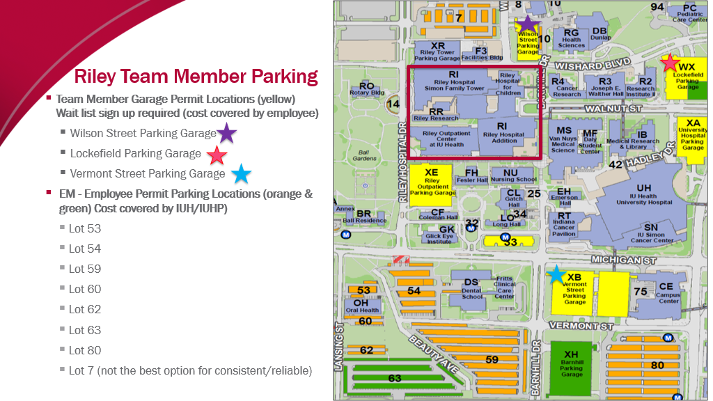
For additional information:
Permits: Parking: Parking and Transportation Services: IUPUI
For general questions:
Contact the Riley Parking Task Force, rileyparking@iuhealth.org.

